2540 North Lincoln Avenue Chicago, Illinois 60614 apollochicago.com
Professionally managed by Rob Kolson Creative Productions, Inc.

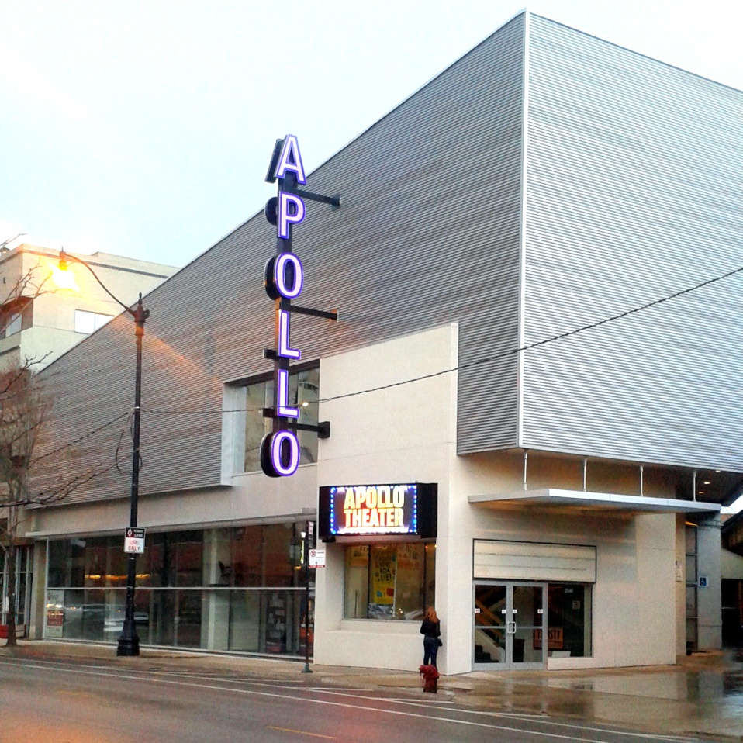
Located in the heart of Chicago's Lincoln Park since 1978, Apollo Theater Chicago has been home to many of the city's biggest hits including, most recently, Million Dollar Quartet, which became the longest-running Broadway musical in Chicago history. Recently renovated and fully accessible, Apollo Theater Chicago's intimate 435-seat mainstage continues to deliver world-class theater as one of the city's premiere off-Loop houses.

Configuration:
The Apollo Theater is a three quarter thrust configuration. There are four aisles, each between seating sections with wheelchair accessible seating just inside the main entrance. All patrons enter at ground level between sections two and three. Latecomers may be brought into the theater using the rear entrance at the top of the seating sections.

Capacity:
⬥ 433 fixed seats
⬥ 2 removable accessible seats
⬥ option for 14 seats added as row AA
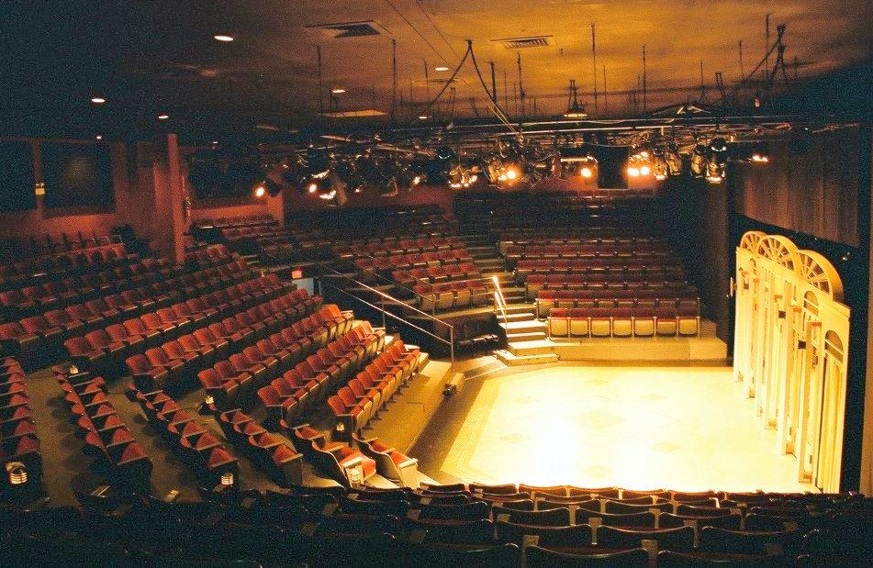
(in front of sections 1, 3, & 5)

Specifications:
 7,000 square feet
 Proscenium: 32' wide by 17' 4" high
 Stage depth: 28' deep (23' with a row AA)
 Stage right wing: 7' wide by 7' deep
 Stage left wing: 20' wide by 8' deep
 Approximately 896 square foot playing area
 Band loft: 13'wide by 7'deep
(fits up to 4 musical performers and instruments)
 Stage floor is lobby level. Floor is
composed of a hardboard surface laid
over 1" foam core.
 Light grid is 17' above stage level. Grid
extends over rows A-D in center
sections and A-B in side sections.

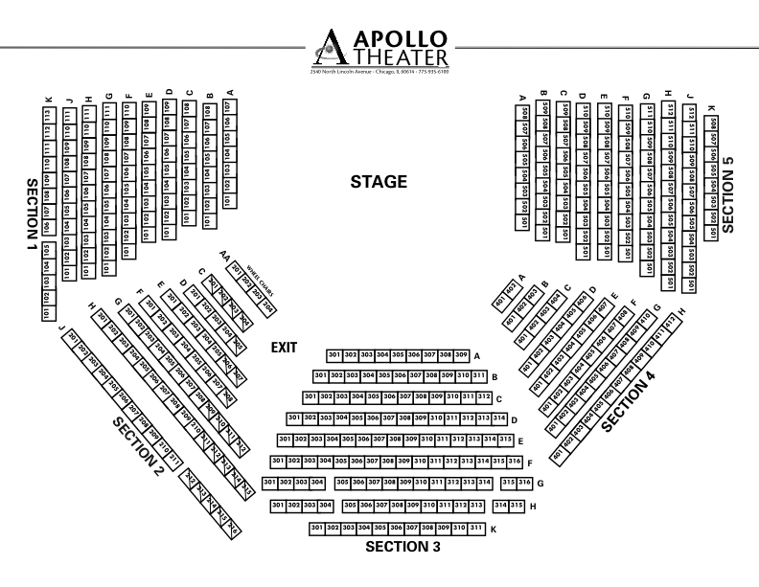

Rental Rates:
 $18,000 per week (primary tenant)
 $3000.00 per day (plus labor expenses)
 $2000.00 per day for non-profit
organizations (plus labor expenses) orgzations
(plus labor expenses)

Additional Charges:
 Ticketmaster and credit card fees
 Utilities
 Percentage of usher payroll
 Technical personnel (based on need)
 Additional equipment
 Apollo marketing (optional)

Rentals include the following:

⬥ Lighting and sound packages using existing
equipment. Inventory below.
⬥ Box office agents, house manager, bartender 
⬥ TicketMaster ticketing software; includes TM
marketing assets and national presence
⬥ Inclusion on LED Marquee, Apollo website and
Facebook page
⬥ Various soft goods, including a black curtain hung on
stage curtain track
⬥ Assistive hearing devices
⬥ Up to three dedicated dressing rooms; two
with full bathrooms, all with lit mirrors.
⬥ Green Room Space
⬥ Laundry facilities: washer/dryer
⬥ Dedicated refrigerator (Primary tenant only)
⬥ Lockable production office (Primary tenant only)
⬥ Lockable stage right storage (Primary tenant only)

To rent the space or arrange a walk-through
please contact Tara Attea, General Manager
(773) 935-9336 tara@apollochicago.com

Lighting Information and Inventory:
The Apollo Theater is equipped with a 96 2.4kw ETC Sensor Dimmers and 96 2.4kw NSI Dimmers. All are controlled by an ETC Ion Console with 2x10 Wings and 2 Monitors.

A fixed 12 Instrument Full Wash is always present in the grid.

Lighting Instruments
High End SolaSpot Pros 1500 | (4) | Martin Rush Par 2 Zooms | (10)
Source 4 50 degrees | (1) 750w | Source 4 50 degrees | (9) 575w
Source 4 36 degrees | (3) 750w | Source 4 36 degrees | (21) 575w
Source 4 26 degrees | (1) 750w | Source 4 26 degrees | (7) 575w
Source 4 19 degrees | (1) 750w | Source 4 19 degrees | (8) 575w
⬥ Complete accessories package, including cabling, gel frames, lenses, iris, gobo holders, top hats, half hats, etc

Sound Information and Inventory:

Sound Instruments
Mixing Console | (1) | Crest X-Eight 24x4x8 | 24x4x8
Speakers: | (3) | EAW MK2194 | 2 way full range
 | (2) | MacPherson M12X | Bi-amp speakers
Fill/Monitors: | (6) | Apogee SSM | Full range
Power: | (4) | Crown Amplifiers
⬥ input devices not included in price, but limited inventory can be rented.

